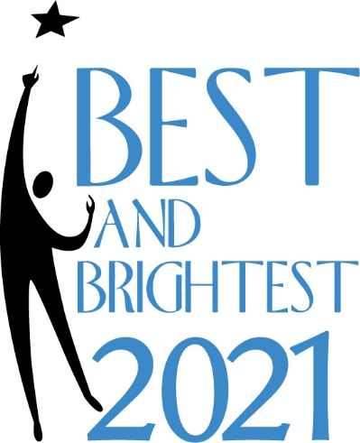
Best and Brightest Application
2021

Thank you for participating in The Gazette’s Best and Brightest 2021! This program is in its 30th year and seeks to highlight the achievements of extraordinary high school seniors in the Pikes Peak region.
The ideal applicant will have:
- A minimum 2.5 GPA
- Displayed a commitment to community service
- The ability to articulate a vision for himself/herself and the future

Applications must be completed by the student applying, and those submitted prior to the deadline will be evaluated by a panel of community leaders. The 2021 class will be announced in The Gazette on Sunday, April 18th to be followed by individual profiles in the newspaper to run daily from April 26th to May 15th, 2021.

CHECKLIST OF REQUIRED APPLICATION MATERIALS
- Complete all the questions in the application. You will type some of your answers directly in this form and others will be on separate pages.
- Enclose one (only one, please) sealed letter of recommendation from anyone in your life. It can be a guidance counselor, teacher, community leader, boss, peer, etc.
- Enclose a sealed transcript or ask your registrar to send it to the address below. Be sure it includes the most recent semester, even if grade is “in progress.” Also include available ACT and SAT scores.
- Enclose your senior picture or a photo suitable for publication in the newspaper. IMPORTANT: Please write your name on the back of your photo. If you would like your photo returned, please include a self-addressed stamped envelope.
- Staple all pages of your application together in one packet and mail or deliver to:
Due to COVID-19 restrictions, The Gazette lobby is currently closed to visitors. If you choose to deliver your application in person, a drop box will be available in the foyer.

The Gazette
Attn: Best and Brightest
30 E. Pikes Peak Avenue, Suite 100
Colorado Springs, CO 80903

Office Hours: Monday-Friday, 9:00 am-4:00 pm

All applications must be received in our office by
4:00 pm Friday, April 9, 2021

IMPORTANT DATES
April 9, 2021 Application must be received at The Gazette by 4:00 pm.
April 25, 2021 Best and Brightest students selected will be announced in The Gazette.

April 26-May 15, 2021 Individual stories on each Best and Brightest student selected will publish in The Gazette.

CONTACT US
If you have questions about the application, please contact: Kelly Spieker, Marketing Coordinator, The Gazette/Gazette Charities: (719)476-4840 or kelly.spieker@gazette.com.

BASIC INFORMATION

Student’s name:

Children and siblings of Gazette employees are not eligible to participate.

Name(s) of parent(s)

or legal guardian(s):

Street address:

City and zip:

Home phone number:

Email address:

School and district:

“I verify that all the information I have provided on my application is accurate.”

Signature of applicant: Date:

Parent or guardian:

“I have read the information provided on this form and to the best of my knowledge it is correct. I consent to the publication of the name and photograph of my child, and of any of the information provided in this package.”

Signature of parent or guardian: Date:

Daytime telephone number: ______
Parent e-mail address:

Your name: School:

ACADEMIC INFORMATION

Cumulative GPA weighted: (Minimum of 2.5 GPA is required for this program)

ACT scores:

SAT scores:

Where are you attending college? If you have not decided, where have you been accepted?

Academic Honors and Achievements: List all academic honors and achievements in the past three years. You may create additional boxes as needed.
Dates | Honor or Achievement

TELL US MORE ABOUT YOURSELF
Please answer the questions below using a maximum of four pages double-spaced for all three answers combined. Please answer each question separately, indicating each answer with the subject/question as a heading. Include your name and school on each page.

- COMMUNITY SERVICE – How do you contribute to our community?

- DEFINING MOMENT – What obstacles have you faced and how did you deal with that experience?

- VISION – What is your goal for the future and how do you hope to impact your community?

LETTER OF RECOMMENDATION
Please provide one typed, sealed letter of recommendation from anyone in your life (guidance counselor, teacher, community leader, boss, peer, etc.). Directions for your reference are as follows: In your letter, please state how long you have known the applicant and in what context. Write whatever you think is important about the individual, including a description of academic or personal characteristics. Mention specific incidents or anecdotes when possible. We are particularly interested in the student’s contribution to school and community, intellectual promise, ability to overcome obstacles, motivation, integrity, leadership potential, special talents and enthusiasm. Please include your phone number or e-mail address.

SUBMITTING YOUR APPLICATION
Please refer to the checklist on the front page to make sure you have everything you need to submit your application by the 4:00 pm April 2, 2021 deadline. No exceptions will be made.

